CCDF-USA Williamson County – Election Resources

https://freedom-to-tinker.com/2023/02/16/unrecoverable-election-screwup-in-williamson-county-tx/?fbclid=IwAR2ABISz4wzWlglbUIcCY_Rl0GOo9V5cWYKtGWLnG7ZiWor73LblVXNAL4U

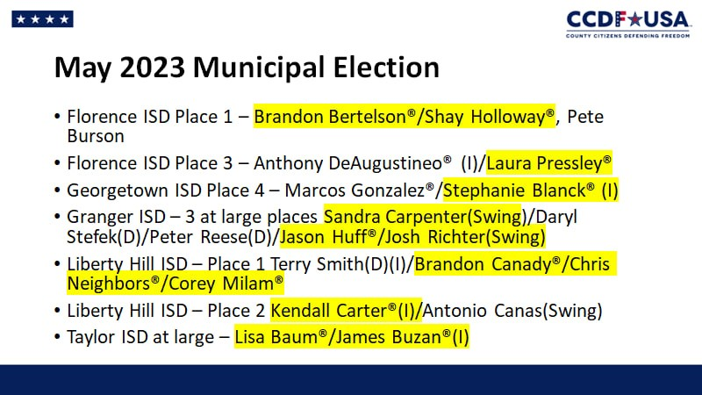

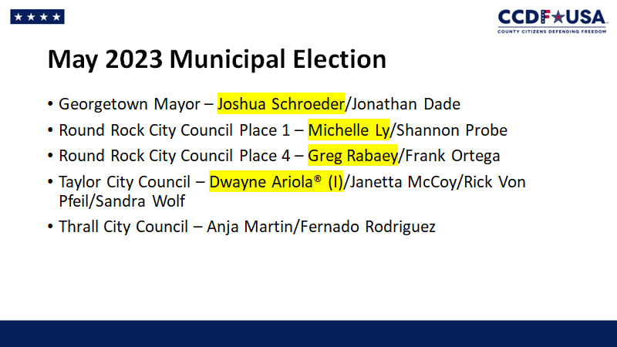

Next Election: Saturday, May 6, 2023
ELECTION DAY: Saturday, May 6, 2023
EARLY VOTING: Monday, April 24, 2023 to Tuesday, May 2, 2023
VOTER REGISTRATION DEADLINE: Thursday, April 6, 2023
LAST DAY TO APPLY TO VOTE BY MAIL: Tuesday, April 25, 2023
CLICK HERE FOR TX SOS ELECTION LAW CALENDAR
Dates and Times for Full-Time Locations and Limited Ballot Voting (Fechas y horarios para localidades de tiempo completo
Monday, April 24 through Saturday, April 29 (Lunes 24 de abril al Sabado 29 de abril) - 8:00 am to 6:00 pm
Sunday, April 30 (Domingo 30 de abril) - No voting (sin votar)
Monday, May 1 through Tuesday, May 2 (Lunes 1 de mayo al Martes 2 de mayo) - 7:00 am to 7:00 pm
Main Location - ubicación principal
Georgetown: Georgetown Annex, HR 108, 100 Wilco Way, 78626
Full-Time Branch Locations – ubicaciones de sucurales
Austin: Anderson Mill Limited District, Room A, 11500 El Salido Parkway, 78750
Cedar Park: Cedar Park Public Library, Community Room, 550 Discovery Boulevard, 78613
Cedar Park: Cedar Park Randalls, 1400 Cypress Creek Road, 78613
Georgetown: Georgetown ISD Technology Building, Conference Room, 603 Lakeway Drive, 78628
Georgetown: The Oaks Community Center-Sun City, 301 Del Webb Blvd, 78633
Hutto: Wilco Hutto Annex, Suite 200, 321 Ed Schmidt Boulevard, 78634
Jarrell: Jarrell ISD Administration Building, Boardroom, 108 East Avenue F, 76537
Leander: Leander Public Library Annex, 1011 S. Bagdad Rd, 78641
Liberty Hill: Liberty Hill ISD Gym Annex, 301 Forest St, 78642
Round Rock: Allen R Baca Center, Bldg 2 room 3, 301 W Bagdad Street, 78664
Round Rock: Brushy Creek Community Center, Maple room, 16318 Great Oaks Drive, 78681
Round Rock: Round Rock Randalls, 2051 Gattis School Road, 78664
Round Rock: Williamson County Jester Annex, Anderson&Harrell room, 1801 E Old Settlers Boulevard, 78664
Taylor: Taylor City Hall, Auditorium, 400 Porter Street, 76574
Limited Ballot Voting – Local de Votación limitada
Georgetown: Georgetown Annex, P105, 100 Wilco Way, 78626
Dates and Times for Part-Time Locations Fechas y horarios para ubicaciones a tiempo parcial
Friday, April 28 through Saturday, April 29 (Viernes 28 de abril al Sabado 29 de abril)
8:00 am to 6:00 pm
Sunday, April 30 (Domingo 30 de abril)
No voting (sin votar)
Monday, May 1 through Tuesday, May 2 (Lunes 1 de mayo al Martes 2 de mayo)
7:00 am to 7:00 pm
Part-Time Branch Locations – ubicaciones de sucurales
Florence: Florence City Hall, Council Chambers, 851 FM970, 76527
Granger: Granger Brethren Church, Fellowship Hall, 306 W Broadway St, 76530

Texas 88th Legislature Bills We Are Tracking
Election Integrity
- HB 39, Murr
- HB 52, Spiller
- HB 125, Slaton
- HB 222, Slaton
- HB 239, Slaton
- HB 397, Goldman
- HB 589, Toth
- HB 678, Bell, Keith
- HB 919, Slaton
- HB 1243, Hefner
- HB 1576, Leo-Wilson
- HB 1671, Jetton
- HB 1735, Leach
- HB 2020, Oliverson
- HB 2192, Murr
- HB 2299, Holland
- HB 2536, Toth
- HB 2619, Tinderholt
- HJR 98, Tinderholt
- HJR 110, Isaac
- SB 2, Hughes
- SB 166, Hughes
- SB 823, Bettencourt
- SB 1039, Bettencourt
- SB 1195, Hughes
- SB 1338, Hall
- SJR 35, Birdwell
Border Security
- HB 82, Spiller
- HB 209, Slaton
- HB 2396, Guillen
- HB 209, Slaton
- SB 237, Hall
Ban Gender Modification of Children
- HB 41, Toth
- HB 42, Slaton
- HB 122, Toth
- HB 672, Hefner
- HB 776, Harrison
- HB 888, Slawson
- HB 1532, Schatzline
- HB 1686, Oliverson
- HB 1752, Toth
- SB 14, Campbell
- SB 249, Hall
- SB 250, Hall
- SB 625, Campbell
- SB 1029, Hall
- SCR 3, Hall
Stop Sexualizing Texas Kids
- HB 111, Toth
- HB 151, Slaton
- HB 231, Swanson
- HB 478, Hull
- HB 552, Troxclair
- HB 571, Leo-Wilson
- HB 858, Slaton
- HB 869, Hefner
- HB 976, Patterson
- HB 1253, Shaheen
- HB 1404, Shaheen
- HB 1507, King, Ken
- HB 1655, Patterson
- SB 162, Perry
- SB 163, Campbell, Hughes
- SB 391, Hall
- SB 393, Hall
- SB 395, Hall
- SB 417, Paxton
- SB 437, Middleton
- SB 828, Hall
- SB 959, Campbell
Abolish Abortion
- HB 60, Vasut
- HB 61, Noble
- HB 319, Oliverson
- HB 574, Leo-Wilson
- HB 787, Patterson
- HB 2690, Toth
- HB 2709, Slaton
- HB 2764, Slaton
- HB 2765, Slaton
- SB 300, Hall
- SB 314, Hall
- SB 511, Hall
- SB 953, Perry
- SB 959, Campbell
Defend Gun Rights
- HB 175, Schaefer
- HB 192, Schaefer
- HB 325, Toth
- HB 356, Bell, Cecil
- HB 636, Patterson
- HB 716, Cain
- HB 2705, Hayes
Parental Rights and Education
- HB 360, Toth
- HB 557, Vasut
- HB 613, Vasut
- HB 631, Toth
- HB 777, Vasut
- HB 807, Harrison
- HB 1149, Swanson
- HB 1658, Capriglione
- HB 2790, Dean
- HB 3164, Tepper
- HJR 37, Vasut
- HJR 38 Vasut
- SB 165, Campbell
- SB 176, Middleton
- SB 298, Hall
- SB 394, Hall
- SB 400, Hall
- SB 420, Paxton
- SB 595, Kolkhorst
- SB 654, Hall
- SJR 29, Paxton
- SJR 72, King

https://www.facebook.com/groups/373150808290938/permalink/504895148449836/

Education

Round Rock ISD
No Recourse: Parent Empowerment for All
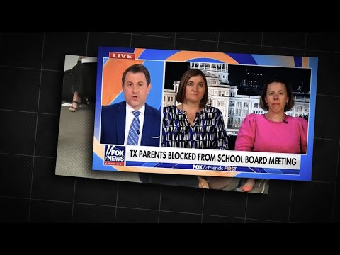
Leander ISD
https://www.facebook.com/christine.huelskampmuat/posts/pfbid02dPVbVZ22KBWsecaHsc4wJtTq8iqCEc4Mjff7E5wtZ5iYVwa2nPnmqCd9C5rz2iFXl

The district can not continue to get away with hiding the truth about what's happening in our schools on a daily basis.
Side note - Leander MS had a drug bust on campus yesterday.
https://m.facebook.com/story.php?story_fbid=10225234797751779&id=1076408312&mibextid=Nif5oz

